UDHAV DAS MEHTA (BHAI JI) CENTRAL REGIONAL CENTRE

Gram Gora, Bishenkheri, Suraj Nagar, Bhopal (MP)- 462044 Email: - rdsaibho-mp@gov.in

File No.:19-15015/5/2022-RC Bhopal-Legal Division Dated : 25.06.2024

EXPRESSION OF INTEREST
EMPANELMENT OF LEGAL COUNSEL(S) FOR SAI, CRC, BHOPAL

The Sports Authority of India (SAI), an autonomous body under Ministry of Youth Affairs & Sports, Government of India proposes to invite applications for an empanelment of Legal Counsels for the SAI, CRC, Bhopal to represent on its behalf before the Hon’ble High Court at Jabalpur, District and Sessions Court, Tribunals, Commission and in all other Courts at Bhopal in the following categories:

- Service matters
- Non-Service matters
- Labour matters
- Sports related matters
- Arbitration matters.
- Contracts, Agreements, Intellectual property Act and Copy Right
- Any other Miscellaneous matters.

SAI intends to engage Legal Counsel (s) for defending court cases on behalf of the Sports Authority of India CRC, Bhopal in Bhopal before the District and Sessions Court, Tribunals, lower courts, and other courts of law/tribunals/forums and also the High Court at Jabalpur. The services of the panel of Legal Counsels will also be utilized for seeking advice, vetting of documents, drafting of MoUs / agreements, contracts, Speaking Orders, reply to Legal notices etc. As per the requirement that arises in crucial cases, the Legal Counsels may have to represent SAI in Courts out of Bhopal.

The eligible and desirous Legal Counsels having the following qualifications and experience may apply as per the prescribed format in Annexure A along with the enclosing self-attested documents showing length of experience, empanelment in government organization / Institutions / Govt. department / PSUs / Bank, enrollment certificate and any other documents as desired by the Counsel.

Interested Legal Counsels fulfilling the requirements are invited to submit their application for empanelment as per Annexure A & B.

ELIGIBILITY CRITERIA

  - Legal Counsel registered with Bar Council of India/State Bar Council Association for at least 05 years from the date of this EOI.

  - Legal Counsel must have experience of working in at least one government organization / Institutions / Govt. department / PSUs / Bank. The empanelment letter of the same is to be attached with the application being submitted by the individual.

  - Legal Counsel located in Bhopal and have a well-equipped office in Bhopal.

  - The empanelment is strictly for professional services of experienced Legal Counsel in their personal capacity. The Law firms or any individual applicant representing the Law firm shall not be entertained.

TENURE

  - The initial tenure of empanelment of the Legal Counsel will be for two (02) years

  - The tenure may be extended by another one year on mutual consent; however, it is purely based on performance review.

TERMS AND CONDITIONS RELATING TO FEE

  - The empaneled Legal Counsel would be paid fee as per the OM No. 26(1)/2014/JUDL. Dt. 01.10.2015 of Ministry of Law & Justice, Dept. of Legal Affairs and the Office Memorandum dated 16.11.2022. OM issued by SAI dated 16.11.2022 attached at attached at Annexure C

  - All payments will be made in INR.

  - No interest shall be paid for any delayed payment.

  - Legal Counsel should submit the bill by the 28th of every month along with details regarding Court order, Cause list or e-mail trail for drafting and legal opinion.

  - No retainer fee shall be paid to SAI Panel Counsel

HOW TO APPLY

  - Eligible Legal Counsels who are located at Bhopal and interested to work with SAI are requested to apply in the format prescribed at Annexure A & Annexure B and no other format of application will be accepted.

  - The application should be sent by email rdsaibho-mp@gov.in with the subject ‘Application for empanelment of Legal Counsel in SAI, CRC, Bhopal’

  - The application should reach by email within 20 days from the date of publication of EOI. Any application received after the cut-off date will not be considered / entertained.

  - The Legal Counsel will be required to furnish the following set of documents:

    - Application form as prescribed at Annexure A & B
    - Detailed Bio-data
    - Copy of Degree in Law.
    - Copy of Enrolment certificate issued by Bar Council.
    - Copy of identity card issued by Bar Association/Council.
    - Copy of office order/letter of empanelment issued by other PSUs/Government Bodies etc.

RIGHTS OF SAI

The SAI, CRC, Bhopal reserves the right to:

  - Cancel this notice at any stage of the process without assigning any reason thereof and no claim/dispute in this regard shall be entertained;

  - To reject any / all applications without assigning any reason thereof;

  - To relax or waive any of the conditions stipulated in this document as deemed necessary in the best interest of SAI without assigning any reasons thereof;

GENERAL TERMS & CONDITIONS

  - The empanelment of the Legal Counsel shall be the sole discretion of the Sports Authority of India, CRC, Bhopal. No person(s) will have any claim for being empanelled. SAI reserves the right to empanel more than one Legal Counsel and assigned them job(s) as per the requirement which is solely its discretion.

  - As per the OM No. J-12012/2/2017 dated 29/30.06.2017 of Ministry of Law and Justice, cases where Union of India is a party along with an autonomous body (i.e., under the administrative control of Ministry), then the counsel engaged by the Department of Legal Affairs will defend the case on behalf of both Union of India and of the autonomous body. In such circumstance, then the Panel Counsel may be engaged by SAI requires to assist Central Government Counsel on a case basis.

  - If there are a large number of applications received, then suitable criteria will be adopted for shortlisting the Legal Counsel and the panel shall be created based on the personnel interview which will be subsequently scheduled for shortlisted applicants.

  - Legal Counsel’s mere submission of application and fulfilment of Eligibility Criteria does not entitle empanelment nor any claim to this effect can be made.

  - The Legal Counsel shall visit the office of SAI as and when required for discussion on any subject matter of legal importance. The Legal Counsel shall also visit the office of SAI periodically (as directed by SAI) for general discussions and to review the progress of court matters.

  - Quick response in cases of emergency is expected by the empaneled Legal Counsel; even though the situation may arise on holidays/ non-working days.

  - The Legal Counsel shall take all necessary steps to protect the interest of SAI in matters entrusted to it from time to time in complete totality.

  - SAI, may at any time, at its discretion withdraw any case proceeding/matter/brief without assigning any clarification from the Legal Counsel. In such situation, the empaneled Legal Counsel will be required to handover the case papers and provide such other assistance as may be required.

  - The Legal Counsel will not use SAI's name/logo/ Symbol on its letter Head/ Signboard/Nameplate etc.

  - All miscellaneous work such as notarization, photocopying etc. of petitions/counters/judgments will be the responsibility of the Legal Counsel. SAI will provide all documents through e-mail or post only to the Legal Counsel’s office, and it is their responsibility to take prints etc. themselves and may claim the charges thereof.

  - The empaneled Legal Counsel(s) shall maintain absolute secrecy and

confidentiality about the cases of SAI entrusted to them.

  - The empaneled Legal Counsel shall be required to sign an Agreement.

  - SAI reserves the right to verify / cross check the information furnished/submitted by the Applicants.

  - The Legal Counsel will be required to advise SAI on matters incidental to litigation and, when any case is decided against the Authority, give their opinion regarding advisability or otherwise for filing an appeal against such a decision in the interest of SAI.

  - If considered necessary, SAI may engage any Law Officer of the Government to argue the cases on behalf of the SAI/UOI. The Legal Counsel shall be required to assist such law officer as and when required to do so by SAI. The Legal Counsel will however continue to get the fee as admissible in these cases.

  - In case of any misconduct, SAI will take appropriate action against empaneled Legal Counsel which includes filling complaint with the Bar Council and recovery of the financial loss(es) so caused to SAI. Here the word misconduct will have the same meaning as in Advocate Act, 1961.

  - The applicant should furnish an undertaking to the effect that he/ she has not been blacklisted in India or abroad or by any Government Department in the Format as placed at Annexure B.

  - The Panel Counsel shall follow various provisions of Advocate Act, 1961 and abide by the secrecy clause.

  - The empaneled Legal Counsel will be obliged to share their complete communication details including landline numbers, mobiles, email addresses etc. along with the communication details of his / her junior counsel or office attendant for proper coordination.

  - The empanelment of the Legal Counsel is liable to be cancelled due to occurring of any or more of the following conditions / situations:

    - Giving false information in the application for empanelment;

    - Handing over the brief/matter to any other Legal Counsel without prior written permission of the SAI;

    - Failing to attend the hearing of the case without prior intimation with

sufficient reason (s) and not arranging for local counsel;

    - Not acting as per instructions of SAI or going against specific instructions;

    - Threatening, intimidating or abusing any of the employees, officer(s) or representatives of SAI;

    - Committing any act tantamount to contempt of court or professional misconduct;

    - Passing information relating to SAI's case to any third party likely to harm the interest of SAI except the information as permitted under the law;

    - Giving false or misleading information to SAI relating to any proceeding
/case etc.
    - Taking adjournment in any case or not objecting to the adjournment, moved by the opposite party without sufficient reason.

  - The empaneled Legal Counsel is free to undertake private practice which does not interfere with or is not in conflict (direct or indirect) with efficient discharge of its responsibility as an empanel Legal Counsel for SAI.

  - While this document has been prepared in good faith, SAI shall have no responsibility or liability whatsoever in respect of any statements or omissions therein.

  - The existing panel Counsels may also apply afresh

INDEMNITY:

The empaneled Legal Counsel will indemnify against all legal/other obligations of its professionals deployed for SAI's work.

Sd/- Regional Director, SAI, CRC,Bhopal

ANNEXURE-A

EMPANELMENT OF LEGAL COUNSEL IN SAI SAI, CRC, BHOPAL

1. | Name:
2. | Address for Correspondence
3 | Landline No.(off )
4. | Landline No.(Res )
5. | Mobile (s)
6. | E-mail
7. | Permanent Address with Tel. No.
8. | PAN Card No.
9. | Aadhar Card No.
10. | Educational Qualification (Complete details)
11. | Date of Registration Bar Council (Attach copy of enrolment certificate)
12 | Whether Advocate is an AOR  (Yes/NO) (If yes, kindly attach the certificate)
13. | Area of Experience / Practice
14. | Field of Specialization
15 | Government empanelment  (Detail the grade)

16 | Any other achievement worth a mention
17. | Any other information sought in the scope of work

Undertaking

- I also undertake to maintain absolute secrecy about the cases of the SAI required under the Act, Rules, and Regulations there under.
- I agree with the Fee Schedule notified by SAI.

Signature of Legal Counsel
Address (Office & Residence / Chamber)

ANNEXURE-B

DECLARATION

I hereby declare that I have never been penalized by any Bar Council or blacklisted/debarred by any Government Department in any matter / issue. I also undertake to maintain absolute secrecy about the cases of the SAI.

Signature of the Legal Counsel…………………………………
Date & Place …………………………………………………………...
Address (office /chamber)………………………………………….
…………………………………………………………………..
…………………………………………………………………..
…………………………………………………………………..
………………………………………………………………….. Tel. No. ……………………………………………………… Mobile No. ………………………………………………... E-mail ………………………………………………

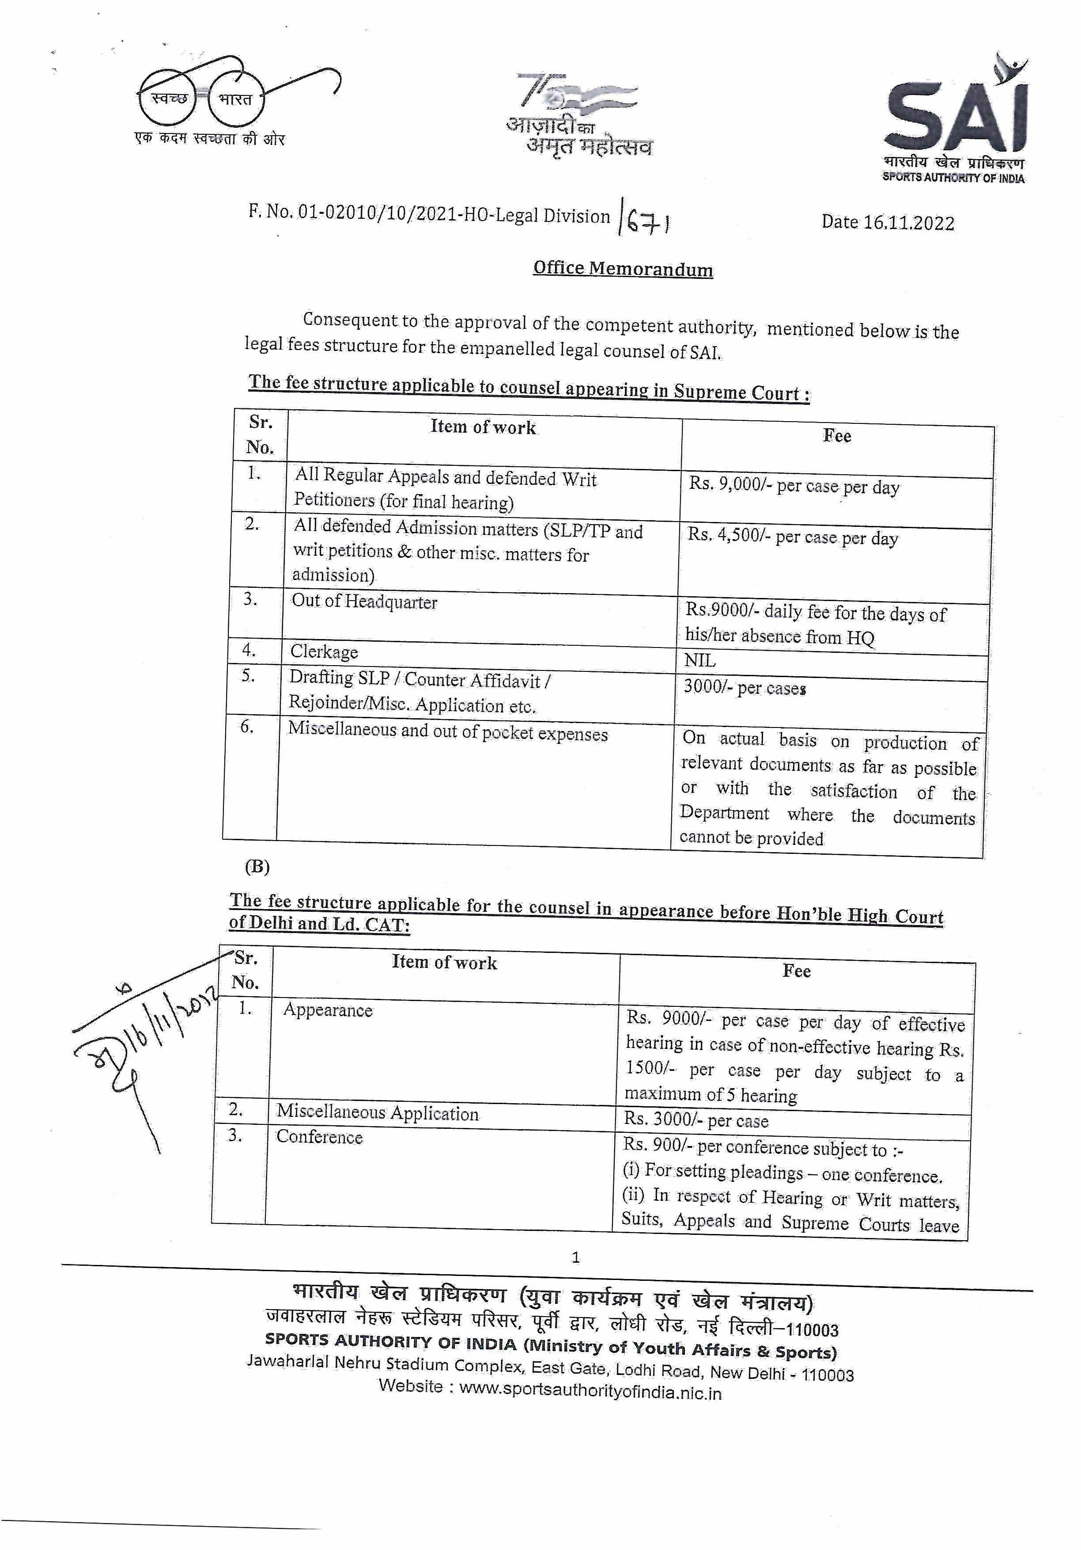
Annexure-C

